DIGITAL CONTENT CREATION
Pre-production checklist

ITEM | STATUS | NOTES
Target Audience map
Persuasive Aim proposal
Storytelling strategy
Creative Format decision (format & platform)
Visual Identity (color palette, fonts, logo, thumbnails, style)
Story script
Story board
Shooting script
Project timeline
Budget

Story script

SCENE | VISUAL | AUDIO | NOTES
1 | Description of the visuals  - Inside / Outside  - Day/Night  - Actions  - Dialogue | Description of the audio:  - Music  - Sound effects | Any notes relevant to have

Target Audience statement:

Persuasive Aim statement:

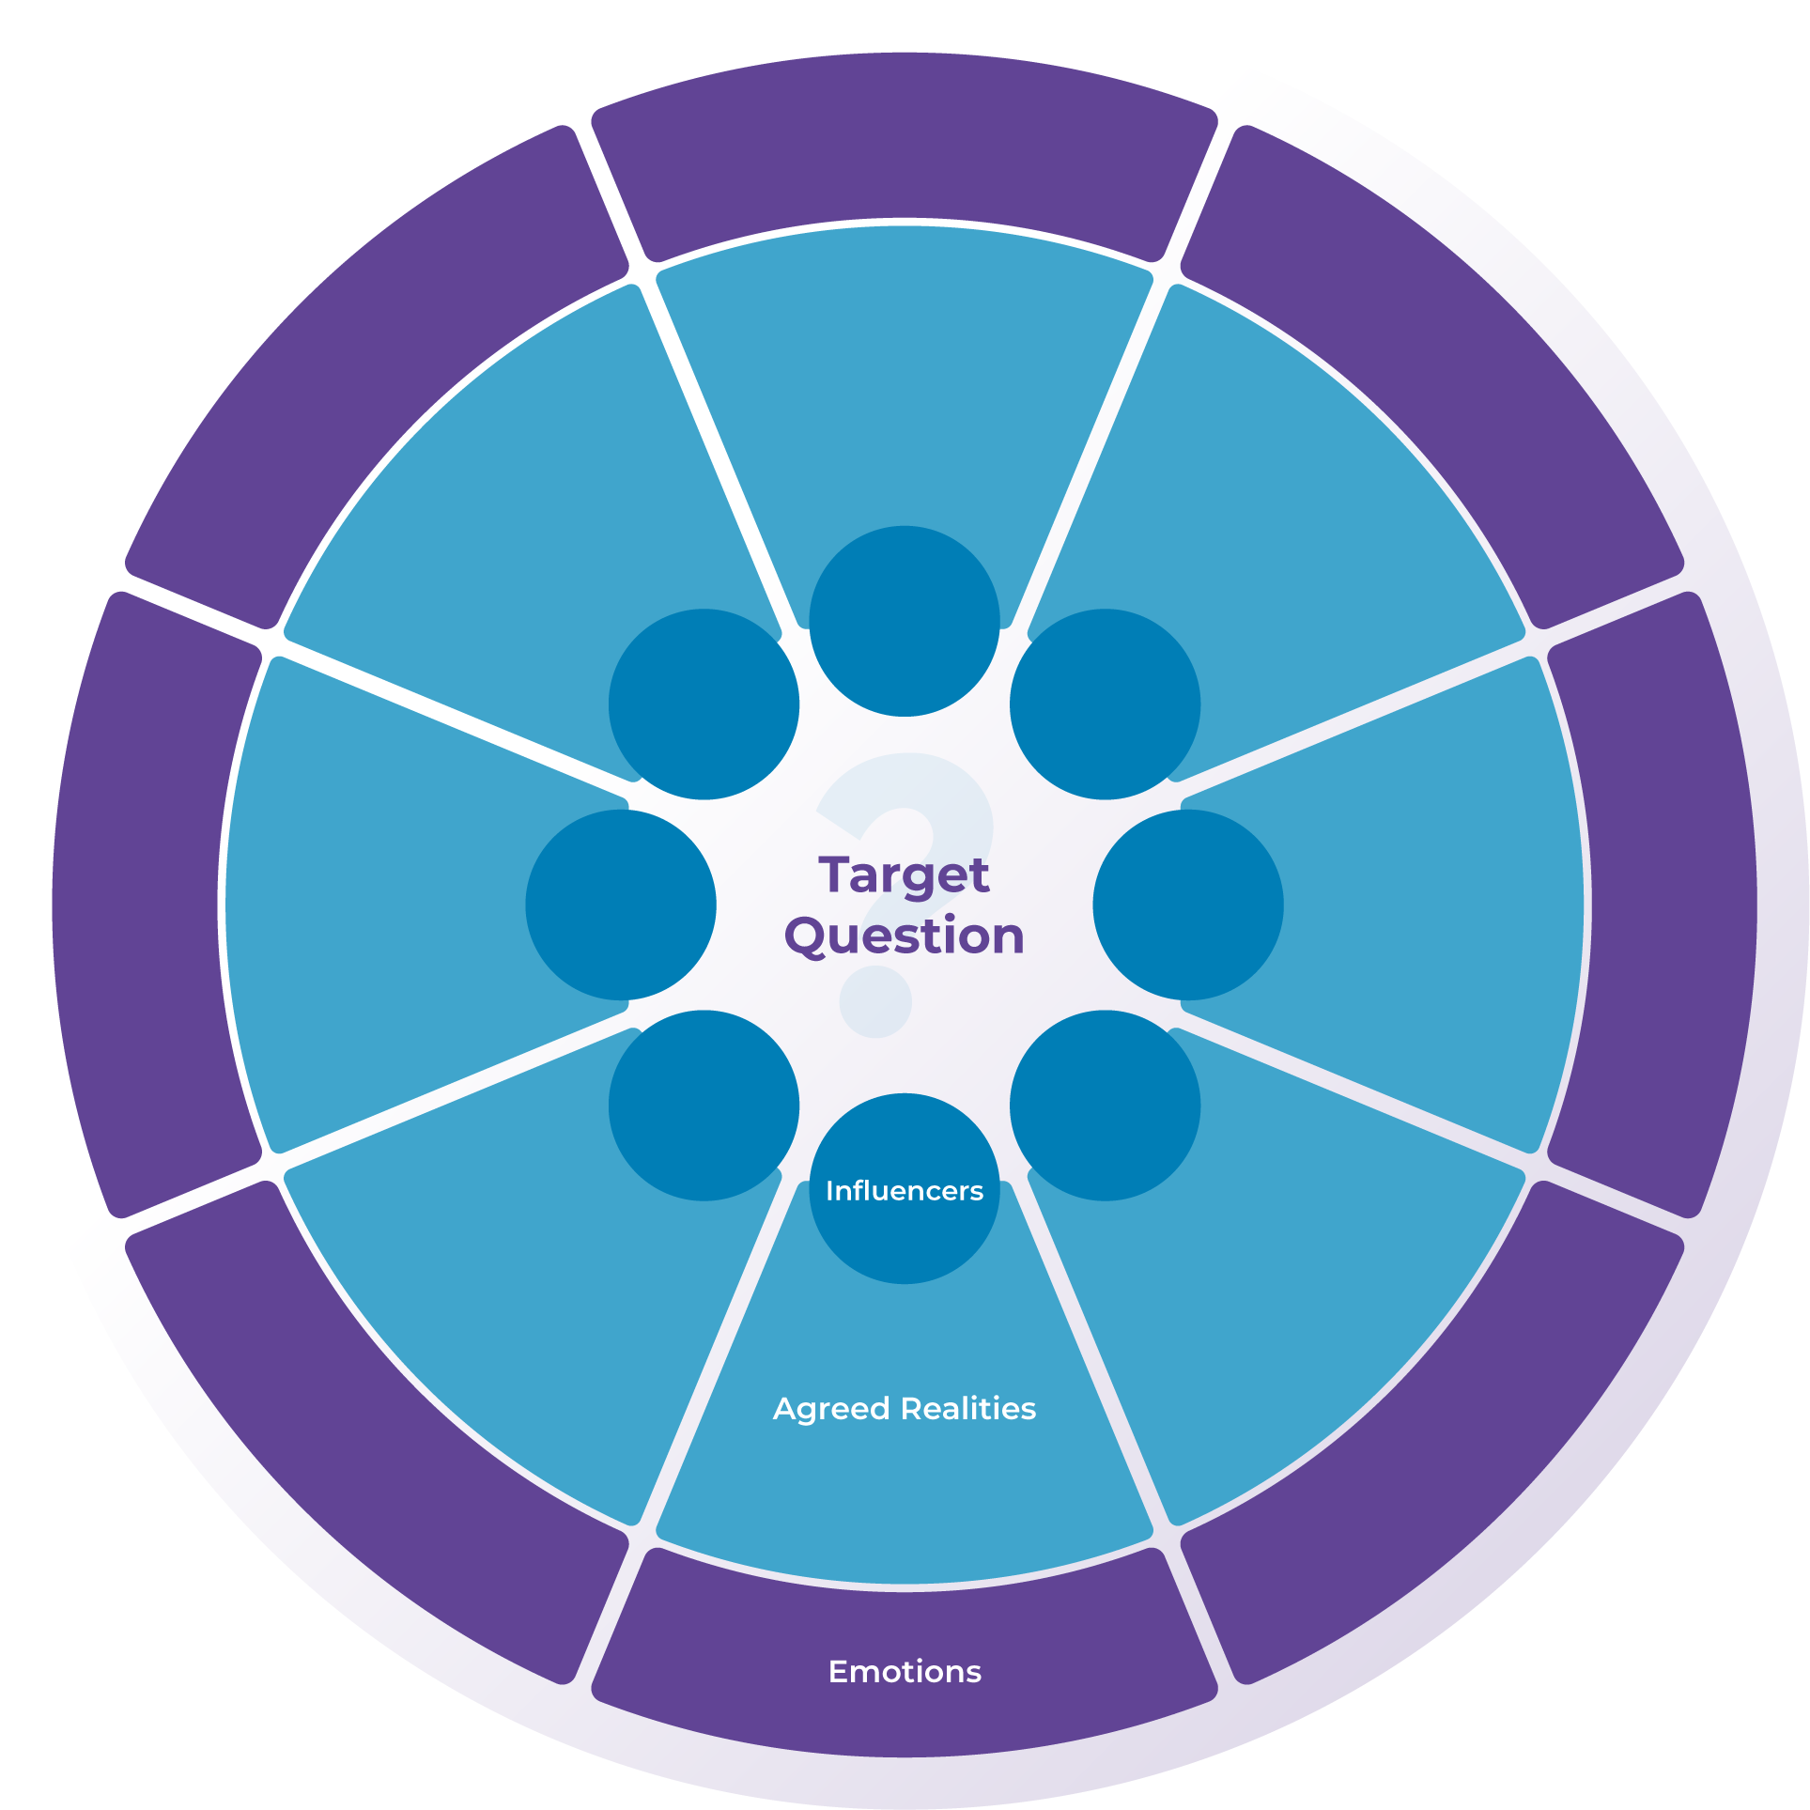

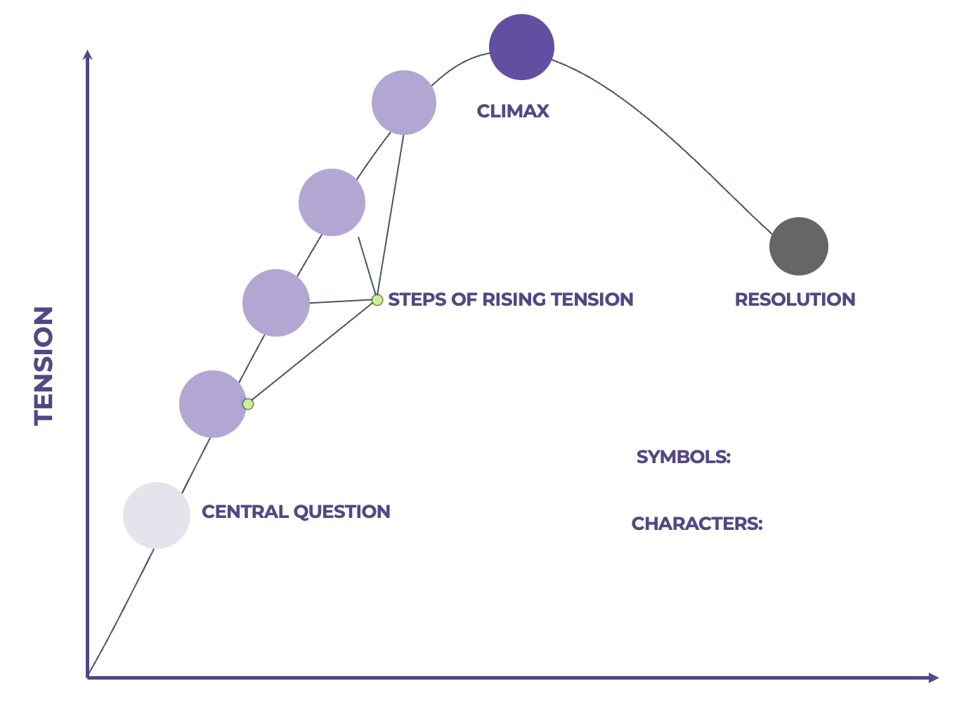

Format:
Medium
Channel/Platform

