RNW MEDIA’S RESPONSIBLE DATA CHECKLIST
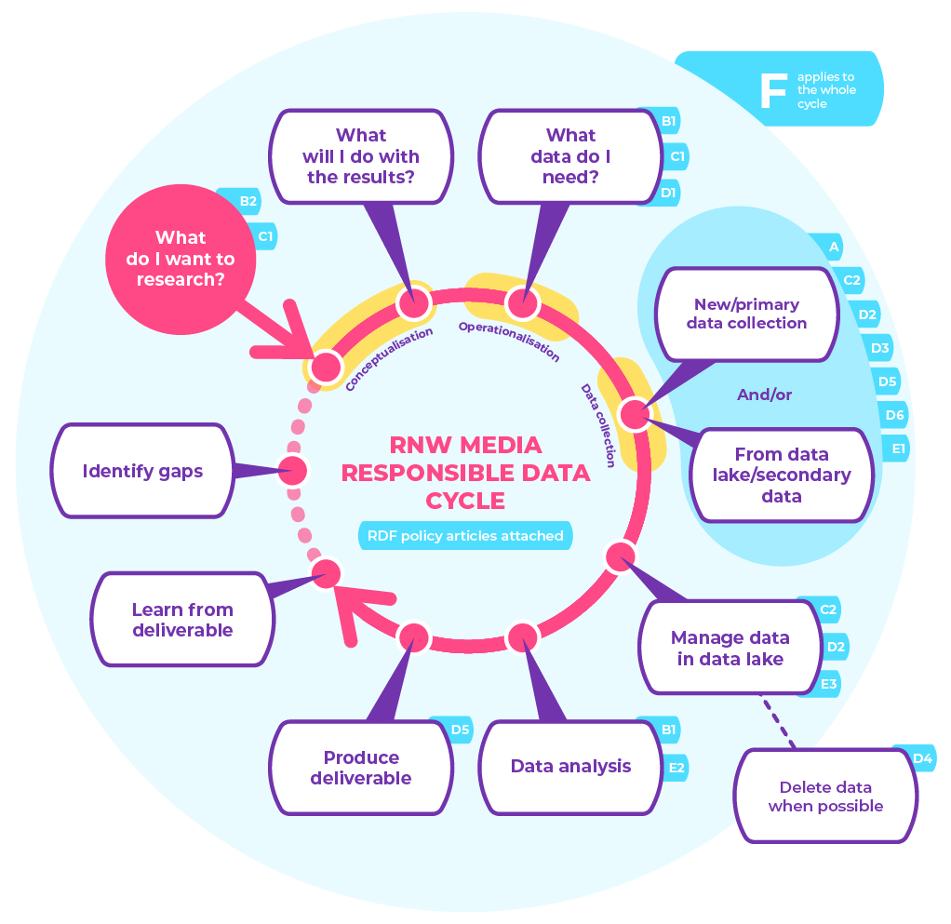

- Conceptualisation

Questions: What do I want to research? And what will I do with the results?

- I have consulted local expertise for this project [B.2.].
- I have documented potential risks to data subjects as a result of data collection [C.1.].
- I have documented mitigation strategies for potential risks to data subjects as a result of data collection [C.1.].

- Operationalisation

Questions: What data do I need?

- I have selected a research sample solely based on 1) my research purpose and 2) organisational capacity [B.1.].
- I have documented my sampling decisions [B.1.].

- Data collection

Either 3.1: PRIMARY DATA COLLECTION

I have a legal basis, either a legitimate interest or consent, for collecting the data. When the collecting of data is based on consent, I have asked data subjects for explicit and written informed consent in line with the informed consent checklist (in Annex III of this policy) [A.1.; A.2.; A.3.].
When consent is the legal basis for the data collection, I have minimised the possibility of negative consequences for data subjects who decide not to participate in the study [A.4.].
I have not disproportionately rewarded study participants [A.4.].
(In cooperation with Digital,) all necessary data protection measures have been taken [C.2.].
I have limited the collection of data to that which is required to answer my research question [D.1.].

Or 3.2: SECONDARY DATA COLLECTION

Either 3.2.1: RNW Media data

I have reviewed the legitimate interest or informed consent form used for the respective dataset [A.1.; A.2.; A.3.].
The legitimate interest or informed consent form used for data collection permits re-use of this dataset for my research purpose [D.3.].
In cooperation with Digital, all necessary data protection measures have been taken and maintained [C.2.].
The dataset selected is still complete and up to date [D.5.]

Or 3.2.2: External data

The dataset selected conforms to RNW Media Data Responsibility standards as listed in this document.

- Data analysis

- I have mitigated sampling biases where possible⁴ [B.1.].
- I have made my sampling biases explicit [B.1.].
- I have mitigated model biases where possible⁵ [E.2.].
- I have made my model biases explicit [E.2.].

- Delivery

- I have not reported any personally identifiable information6 [D.3.].
- I have documented the research limitations and their consequences and have taken the appropriate steps to communicate these with relevant stakeholders [E.2.].

